Part 4; Network time synchronization with NTP
To install the NTP package we use chrony hence the command; sudo dnf install chrony -y
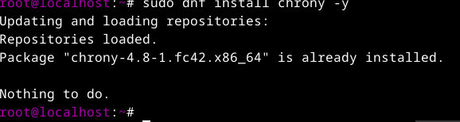
To check status after installation use the command; sudo systemctl status chronyd
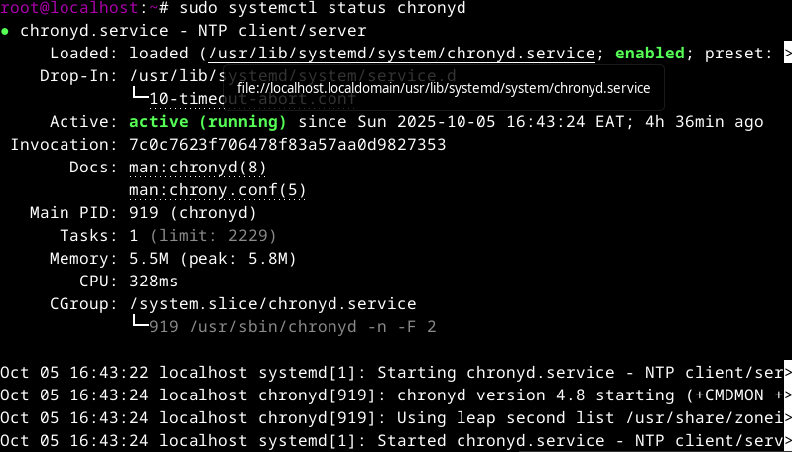
NOTE; The main configuration file is /etc/chrony.conf
To edit the configuration file use the command; nano /etc/chrony.conf
Start and Enable NTP use the command; sudo systemctl start chronyd and sudo systemctl enable chronyd
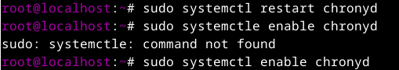
Firewall Configuration If you have the firewall enabled, allow NTP traffic through the command; sudo firewall-cmd --add-service=ntp --permanent and sudo firewall-cmd –reload
Verification Check the status of the NTP service to ensure it's running use the command; sudo systemctl status chronyd

